Brendan Baronia

Melinda Ong

CPE 329-01

Assignment 1: Blinking LED, Clock Control, and Software Delay on MSP432

1. Youtube link of one-second pulse for 6 MHz, 12 MHz, and 24 MHz clock frequencies:  
   <https://youtu.be/bHAuoQa0bXo>
2. Documentation of accuracy of the one-second pulses with three clock frequencies:

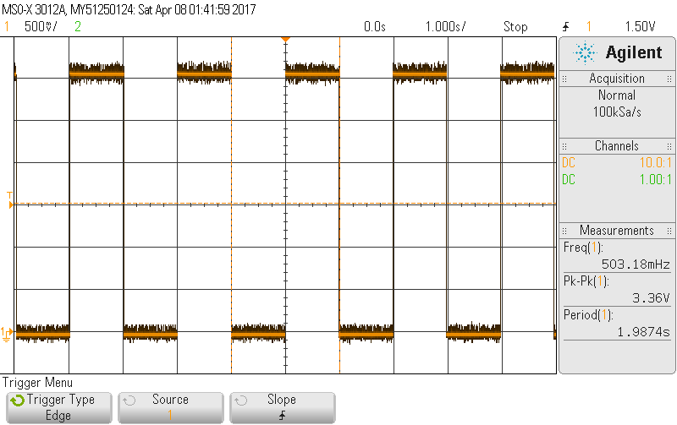  
**Figure 1: One-second pulse with clock cycle at 6 MHz**

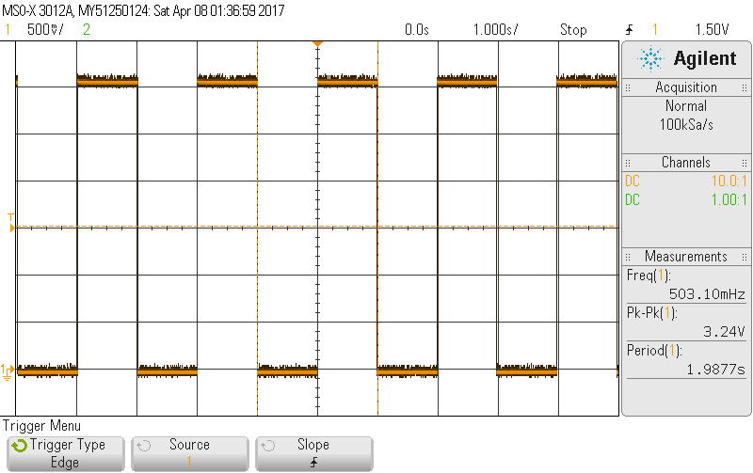  
**Figure 2: One-second pulse with clock cycle at 12 MHz**

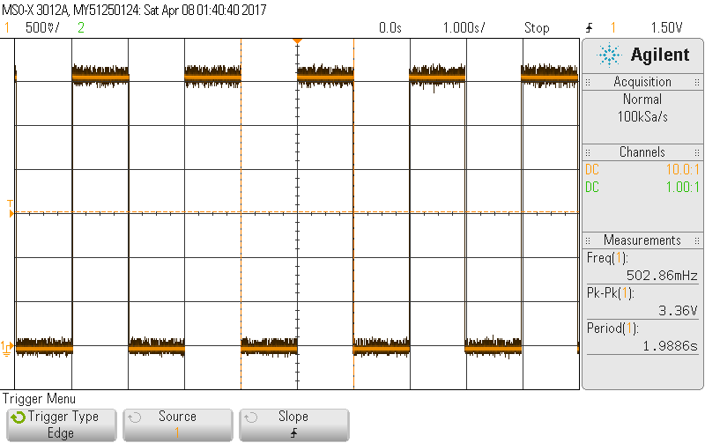

**Figure 3: One-second pulse with clock cycle at 24 MHz**

1. 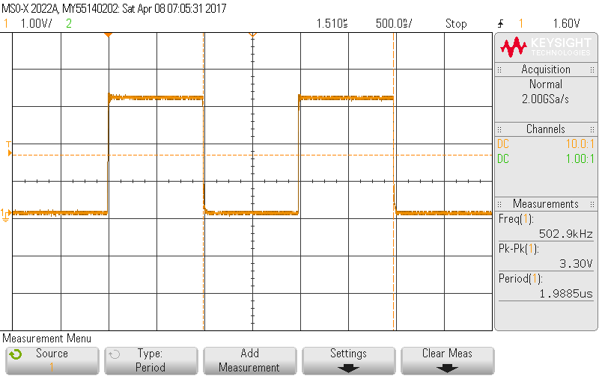  
    **Figure 4: Screenshot of two 1 us pulses using normal triggering**

$Percent Error = \frac{| expected - experimental | }{expected} x 100$

$Percent Error = \frac{| 2- 1.9985| }{2} x 100$

$Percent Error = 0.25\%$

1. Shortest pulse generated:   
    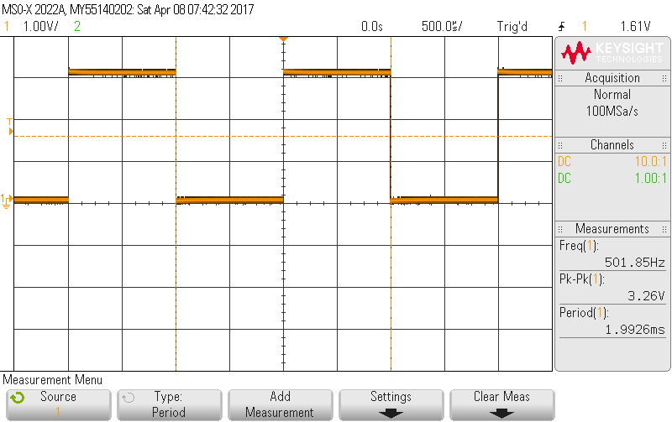

**Figure 5: Delay milliseconds function - 1.99 ms actual period, 2 ms specified**

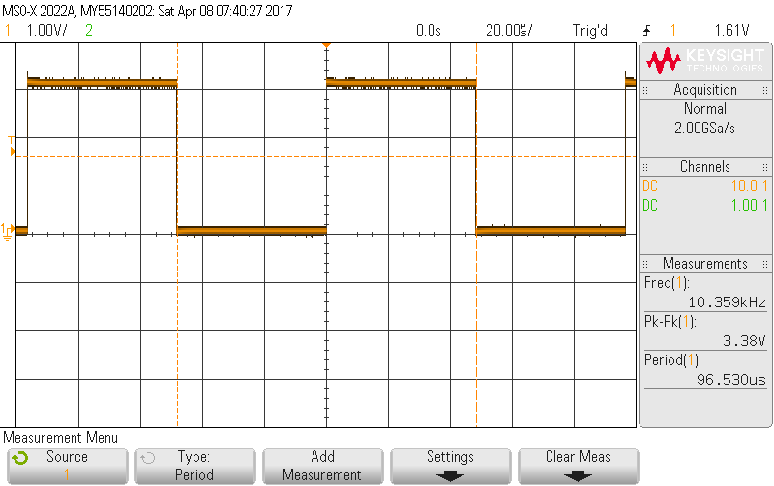

**Figure 6: Delay nanoseconds function - 96 us actual period, 100 us specified**

2. C-Source code for system:

/* P2_1 Toggling green LED in C using header file register definitions.

* This program toggles green LED for 0.5 second ON and 0.5 second OFF.

* The green LED is connected to P2.1.

* The LEDs are high active (a '1' turns ON the LED).

*

* XMS432P401R Rev C.

*/

#include "msp.h"

#define FREQ_1_5_MHZ 1500000

#define FREQ_3_MHZ 3000000

#define FREQ_6_MHZ 6000000

#define FREQ_12_MHZ 12000000

#define FREQ_24_MHZ 24000000

#define FREQ_48_MHZ 48000000

#define MILLI 1000

#define NANO 1000000000

#define FOR_CYCLES 10

#define CALC_TIME 35000;

void delay_ms(int n, int frequency);

void delay_ns(int n, int frequency);

void set_DC0(int frequency);

int main(void) {

int frequency = FREQ_24_MHZ;

P2->SEL1 &= ~2; /* configure P2.1 as simple I/O */

P2->SEL0 &= ~2;

P2->DIR |= 2; /* P2.1 set as output pin */

set_DC0(frequency);

//Method for two 1us pulses

/*

int counter = 1, secCounter = 1, thirCounter = 1;

P2->OUT |= 2; /* turn on P2.1 green LED */

//delay_ns(1000000000, frequency);

while(counter--);

P2->OUT &= ~2; /* turn off P2.1 green LED */

while (secCounter--);

//delay_ns(1000000000, frequency);

P2->OUT |= 2; /* turn on P2.1 green LED */

while (thirCounter--);

//delay_ns(1000000000, frequency);

P2->OUT &= ~2; /* turn off P2.1 green LED */

secCounter = 1;

while (0);

//delay_ns(1000000000, frequency);

*/

while (1) {

P2->OUT |= 2; /* turn on P2.1 green LED */

delay_ms(1, frequency);

P2->OUT &= ~2; /* turn off P2.1 green LED */

delay_ms(1, frequency);

}

}

/* Delays a number of milliseconds

* @param n is the number of ms to delay

* @param frequency is the current clock frequency, as defined

* at the top of this file

*/

void delay_ms(int n, int frequency) {

int i;

int delayTime = frequency / FOR_CYCLES / MILLI;

for (i = delayTime * n; i > 0; i--); /* Delay 1 ms*/

}

/* Delays a number of nanoseconds

* @param n is the number of ns to delay

* @param frequency is the current clock frequency, as defined

* at the top of this file

*/

void delay_ns(int n, int frequency) {

int i;

n -= CALC_TIME;

//Find correct count to delay

int delayTime = 1.0 * frequency * n/ NANO / FOR_CYCLES;

for (i = delayTime; i > 0; i--); /* Delay n*/

}

/* set DCO to a defined frequency

* @param frequency is the clock frequency to set, as defined

* at the top of this file

*/

void set_DC0(int frequency) {

CS->KEY = CS_KEY_VAL; // unlock CS registers

CS->CTL0 = 0; // clear register CTL0

//Switch block to determine and set frequency

switch (frequency) {

case FREQ_1_5_MHZ :

CS->CTL0=CS_CTL0_DCORSEL_0;

break;

case FREQ_3_MHZ :

CS->CTL0=CS_CTL0_DCORSEL_1;

break;

case FREQ_6_MHZ :

CS->CTL0=CS_CTL0_DCORSEL_2;

break;

case FREQ_12_MHZ :

CS->CTL0=CS_CTL0_DCORSEL_3;

break;

case FREQ_24_MHZ :

CS->CTL0=CS_CTL0_DCORSEL_4;

break;

case FREQ_48_MHZ :

CS->CTL0=CS_CTL0_DCORSEL_5;

break;

default:

CS->CTL0=CS_CTL0_DCORSEL_1;

}

CS->CTL1 = CS_CTL1_SELA_2 | CS_CTL1_SELS_3 | CS_CTL1_SELM_3; // select clock sources

CS->KEY = 0; // lock the CS registers

}